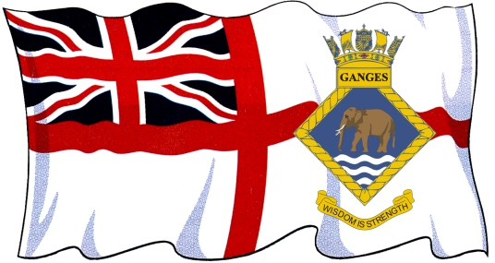 Membership Application Form








Cheques or money orders should be made payable to HMS Ganges Association.

Surname……………………………………………….Forenames……………………………………………………………..

Home Address…………………………………………………………………………………………………………………………

………………………………………………………………………………………………………Post Code………………….…….

Tel No……………………………………………………………………Mobile No…………………………………….………….

Email Address…………………………………………………………………………………………………………………………

Rank or Rating (at end of service)…………………………………………………………………………….………….

Official Number……………………………………….HMS Ganges joining date…………………………………….

Division……………………………………Recruitment ……………..Mess……………………Class……………………

NOK: Surname………………………………………………………… Forenames………………………………………..

Address:…………………………………………………………………………………………………………………………………

……………………………………………………………………………………………………………………………………..

Signature of Applicant……………………………………………………………….Date……………………………………

Please return this form and Standing Order Mandate to: Ken Bushnell, Membership Secretary HMS Ganges Association, 7, Rivers Street, Yew Gardens, Waterlooville, Hampshire, PO7 5FR

All information held by the Association is used to administer your membership and inform you
of any benefits we may provide and will not be disclosed for unlawful or unauthorised use.
By completing this form you consent to your information being held in digital and written formats.

